**Recitation 7**

**Problem 1. A Protocol for College Admission**

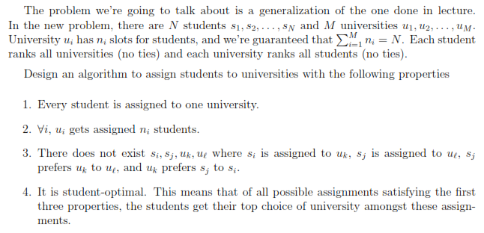

**Each Step in the Application Cycle:**

* Application Submission
  + The Universities invite students to apply
  + Each student applies to the top school on their list. If there are no more schools on their list, they get a job at Petco.
* Evaluation
  + Each university $u_{i}$ says “Maybe, apply again in the next cycle” to its $n_{i}$ favorite applicants this cycle.
  + To the others, each university copy-pastes, “We are sorry to inform you...”
* Evening
  + Any applicant who is denied by $u_{i}$ crosses $u_{i}$ off their list.

**Termination Condition:** If there is a cycle when every university $u_{i}$ has exactly $n_{i}$ applicants, the process stops and those students are assigned to those universities.

1. Show that the algorithm terminates after $NM+1$ days.

Once a university has $n_{i}$ applicants, it will maintain that many applicants for the rest of the process. After every cycle that does not meet the termination condition, at least one student crosses a university off of their list. There are $NM$ entries on all of the students’ lists. A student does not cross a university off of their list unless that university has $n_{i}$ applicants it prefers over that student. Since a university with less than $n_{i}$ applicants could not have been crossed off by any student yet, no student could cross off all universities from their list before being favorited by that university. Thus before the $NM$ entries are crossed off in a maximum of $NM$ days, each student has been matched with a university.

2. Show that if during some cycle a university $u_{j}$ has at least $n_{j}$ applicants, then when the algorithm terminates it accepts exactly $n_{j}$ students.

A student will only apply to a school if it is at the top of their current list. Until $u_{j}$ rejects a student, that student will continue applying to $u_{j}$. And since $u_{j}$ only rejects students if it has $n_{j}$ more preferred applicants, its number of applicants will never decrease after a cycle. At termination, it will continue to have $n_{j}$ applicants to accept.

3. Show that every student is assigned to one university.

A student can only be applying to one university each cycle. The only way a student changes which university they are applying to is by being rejected by the first university, meaning they cross that university off and cease applying to it.

4. Show that for all $i$, $u_{i}$ gets assigned $n_{i}$ students.

The process does not terminate until $u_{i}$ has at least $n_{i}$ students, and $u_{i}$ rejects all students more than its preferred $n_{i}$, so it cannot be assigned more than $n_{i}$ students. Therefore, it is assigned $n_{i}$ students.

5. Show that the rank of $u_{j}$’s worst applicant on a given cycle with full applicants cannot decrease for future cycles.

If there were an applicant ranked worse by $u_{j}$ than its current lowest ranked, matched, applicant, that applicant would be rejected, because applicants are rejected precisely when there are $n_{j}$ preferred applicants above them. And because there are no duplicate rankings, none but a higher-ranked applicant could make it onto $u_{j}$’s shortlist.

6. Show that there does not exist $s_{j}, s_{i}, u_{k}, and u_{l}$ where $s_{i}$ is assigned to $u_{k}$, $s_{j}$ is assigned to $u_{l}$, $s_{j}$ prefers $u_{k}$ to $u_{l}$, and $u_{k}$ prefers $s_{j}$ to $s_{k}$.

For purposes of contradiction, assume that such a matching existed. If $s_{j}$ prefers $u_{k}$ to $u_{l}$, then it must have tried $u_{k}$ first and been rejected. But if $u_{k}$ rejected $s_{j}$, then $u_{k}$’s lowest ranked match (all of its current matches) must have been preferred to $s_{j}$. But then if $u_{k}$ prefers $s_{j}$ to $s_{k}$ and all of its current matches were preferred to $s_{j}$, then $s_{k}$ would have also been rejected. This is a contradiction, so such a matching must not exist.

7. Show that each student is assigned to its optimal university.

For purposes of contradiction, assume that a student $s_{j}$ is not assigned to its optimal university $u_{k}$. This means that of all universities for which there exists some assignment satisfying the first three properties above, the one $s_{j}$ is assigned to is not $s_{j}$’s optimal choice among them. This means that at some point $s_{j}$ was rejected from $u_{k}$. Which would mean $u_{k}$ had $n_{k}$ preferred applicants to $s_{j}$. **But an assignment exists for $s_{j}$ to $u_{k}$, so $s_{j}$ can’t be preferred by $n_{k}$ applicants.** This is a contradiction, and therefore each student is assigned to its optimal university.

**What I wrote above is incorrect because I can’t compare the possible assignments like that. In this assignment $s_{j}$ can be and was preferred by $n_{k}$ applicants at $u_{k}$.** This needs to be demonstrated like is done for the marriage problem in the book, by considering the first student to not be assigned its optimum university and using it to establish $s_{j}, s_{i}, u_{k}, and u_{l}$ across the two possible assignments (the real and the optimal) for application of the previous problem.